NALLASIVAM P V

IT-B

727721EUIT096

QUESTION-1

package cc_1;

import org.openqa.selenium.By;

import org.openqa.selenium.WebDriver;

import org.openqa.selenium.WebElement;

import org.openqa.selenium.chrome.ChromeDriver;

import org.openqa.selenium.chrome.ChromeOptions;

import io.github.bonigarcia.wdm.WebDriverManager;

public class addtocart {

public static void main(String[] args) {

// **TODO** Auto-generated method stub

WebDriverManager.*chromedriver*().setup();

WebDriver driver;

ChromeOptions co = new ChromeOptions();

co.addArguments("--remote-allow-origins=*");

driver = new ChromeDriver(co);

driver.navigate().to("https://www.saucedemo.com/");

WebElement msg= driver.findElement(By.*xpath*("//*[@id=\"user-name\"]"));

msg.sendKeys("standard_user");

WebElement amt= driver.findElement(By.*xpath*("//*[@id=\"password\"]"));

amt.sendKeys("secret_sauce");

WebElement con = driver.findElement(By.*xpath*("//*[@class=\"submit-button btn_action\"]"));

con.submit();

WebElement check = driver.findElement(By.*id*("add-to-cart-sauce-labs-fleece-jacket"));

check.click();

WebElement add = driver.findElement(By.*xpath*("//*[@class=\"shopping_cart_badge\"]"));

add.click();

WebElement out = driver.findElement(By.*xpath*("//*[@class=\"btn btn_action btn_medium checkout_button\"]"));

out.click();

WebElement first= driver.findElement(By.*xpath*("//*[@id=\"first-name\"]"));

first.sendKeys("NALLASIVAM");

WebElement last= driver.findElement(By.*xpath*("//*[@id=\"last-name\"]"));

last.sendKeys("P V");

WebElement pin= driver.findElement(By.*xpath*("//*[@id=\"postal-code\"]"));

pin.sendKeys("641654");

WebElement cont = driver.findElement(By.*xpath*("//*[@class=\"submit-button btn btn_primary cart_button btn_action\"]"));

cont.click();

System.***out***.println("Product:Sauce Labs Fleece Jacket");

System.***out***.println("Price: $49.99");

String title=driver.getTitle();

String url=driver.getCurrentUrl();

if(title.equals("Swag Labs"))

System.***out***.println("Title Verified Successfully");

else

System.***out***.println("Title Not Verified");

if(url.equals("https://www.saucedemo.com/checkout-step-two.html"))

System.***out***.println("URL Verified Successfully");

else

System.***out***.println("URL Not Verified");

}

}

OUTPUT:

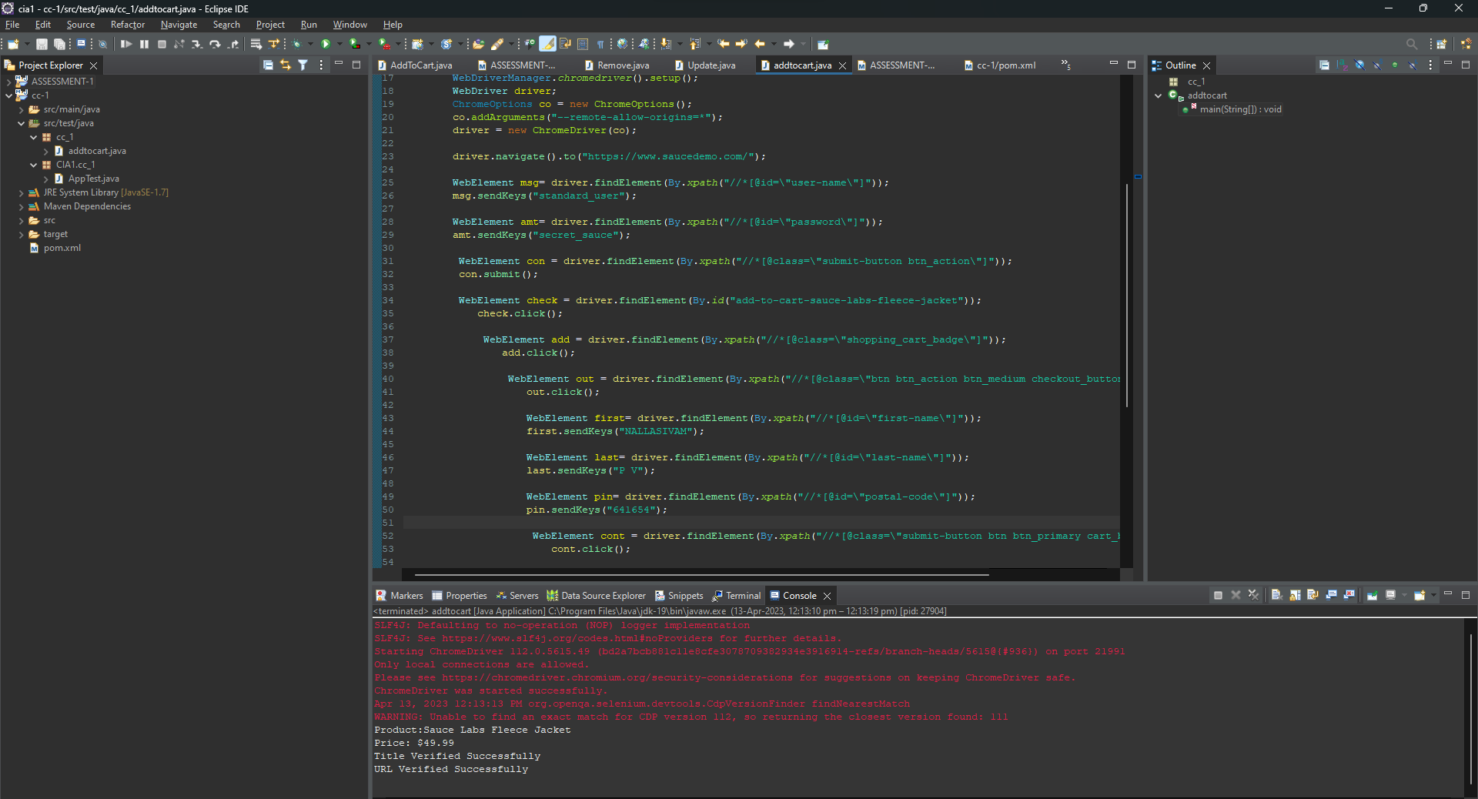

2)

package cc_1;

import org.openqa.selenium.By;

import org.openqa.selenium.WebDriver;

import org.openqa.selenium.WebElement;

import org.openqa.selenium.chrome.ChromeDriver;

import org.openqa.selenium.chrome.ChromeOptions;

import io.github.bonigarcia.wdm.WebDriverManager;

public class Filteroption {

public static void main(String[] args) {

// **TODO** Auto-generated method stub

WebDriverManager.*chromedriver*().setup();

WebDriver driver;

ChromeOptions co = new ChromeOptions();

co.addArguments("--remote-allow-origins=*");

driver = new ChromeDriver(co);

driver.navigate().to("https://www.saucedemo.com/");

WebElement msg= driver.findElement(By.*xpath*("//*[@id=\"user-name\"]"));

msg.sendKeys("standard_user");

WebElement amt= driver.findElement(By.*xpath*("//*[@id=\"password\"]"));

amt.sendKeys("secret_sauce");

WebElement con = driver.findElement(By.*xpath*("//*[@class=\"submit-button btn_action\"]"));

con.submit();

String txt1=driver.findElement(By.*xpath*("//*[@id=\"item_3_title_link\"]/div")).getText();

System.***out***.println(txt1);

driver.findElement(By.*xpath*("//*[@id=\"header_container\"]/div[2]/div/span/select")).click();

driver.findElement(By.*xpath*("//*[@id=\"header_container\"]/div[2]/div/span/select/option[2]")).click();

String txt2=driver.findElement(By.*xpath*("//*[@id=\"item_1_title_link\"]/div")).getText();

System.***out***.println(txt2);

driver.findElement(By.*xpath*("//*[@id=\"header_container\"]/div[2]/div/span/select")).click();

driver.findElement(By.*xpath*("//*[@id=\"header_container\"]/div[2]/div/span/select/option[3]")).click();

String txt3=driver.findElement(By.*xpath*("//*[@id=\"item_4_title_link\"]/div")).getText();

System.***out***.println(txt3);

driver.findElement(By.*xpath*("//*[@id=\"header_container\"]/div[2]/div/span/select")).click();

driver.findElement(By.*xpath*("//*[@id=\"header_container\"]/div[2]/div/span/select/option[4]")).click();

String txt4=driver.findElement(By.*xpath*("//*[@id=\"item_2_title_link\"]/div")).getText();

System.***out***.println(txt4);

}

}

OUTPUT:

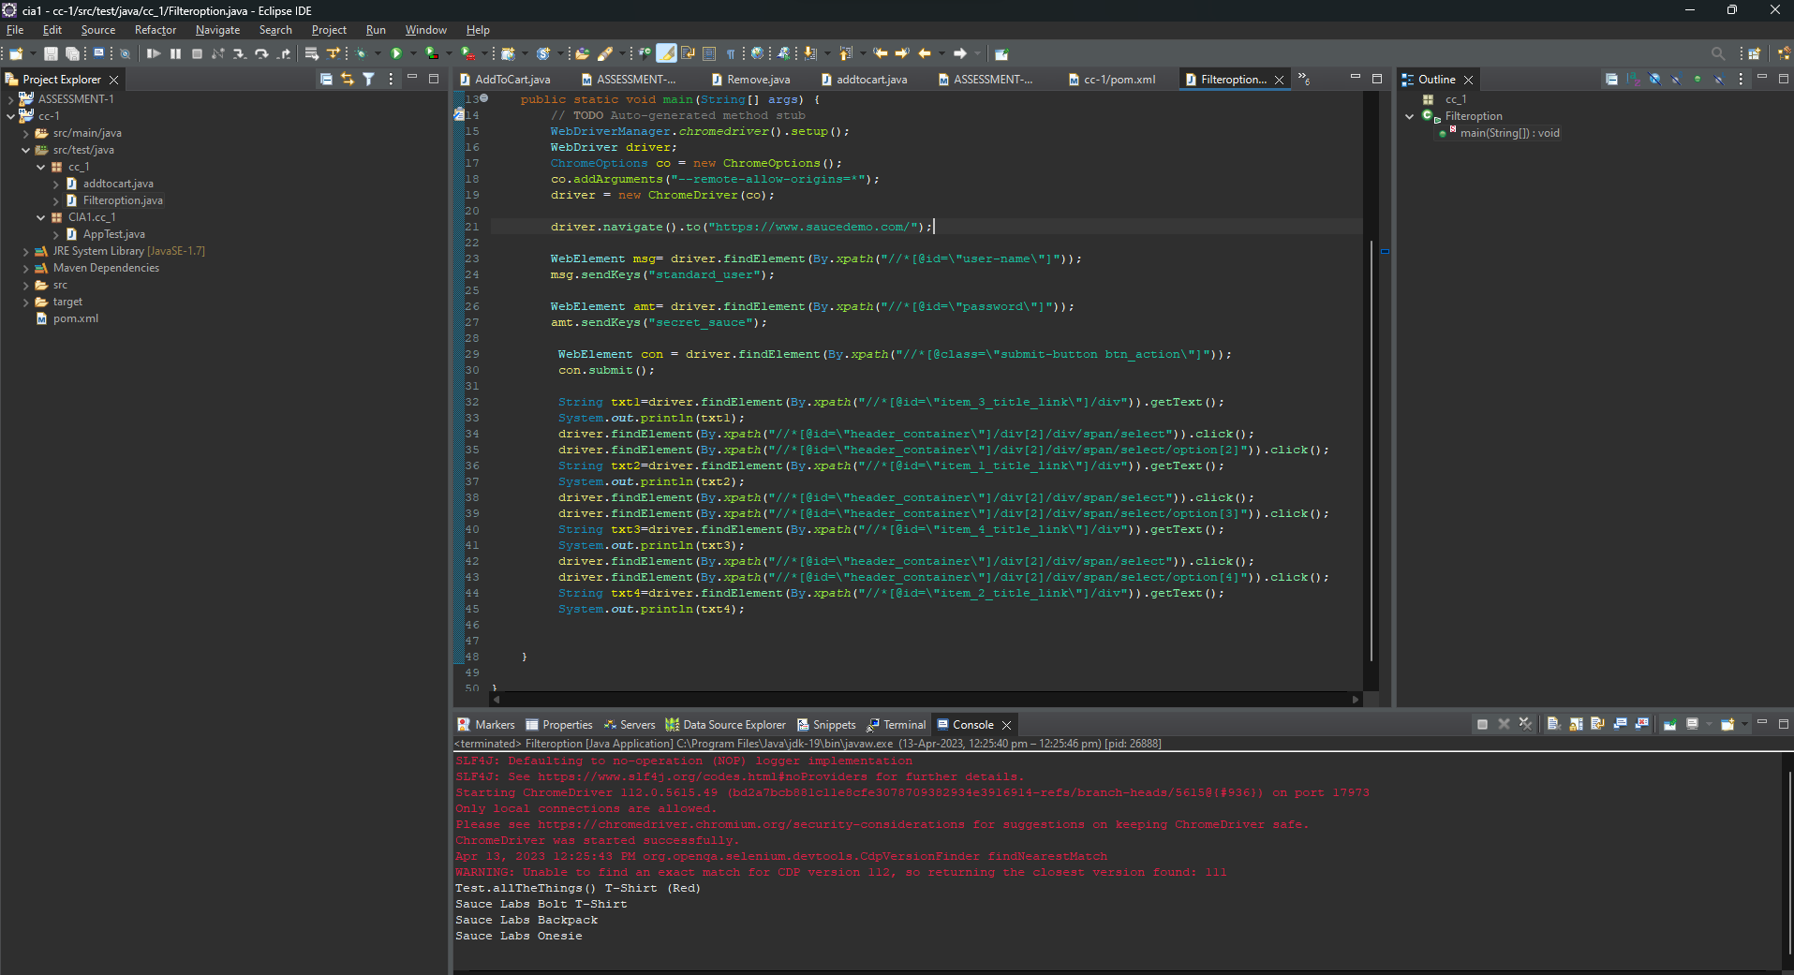

**CA 1**

**Software Testing using Selenium**

**727721EUIT096**

**NALLASIVAM P V**

1.

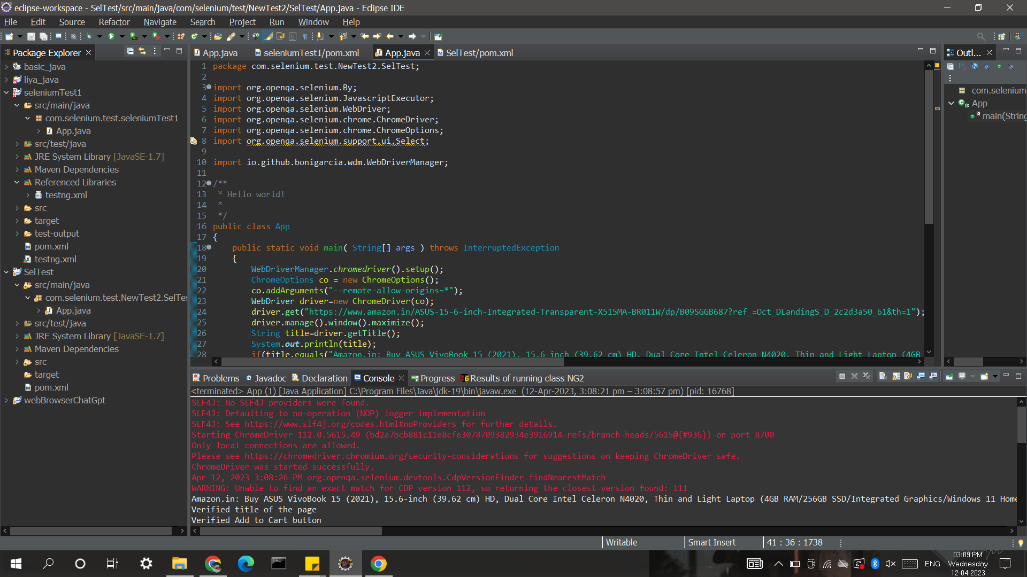

package com.selenium.test.NewTest2.SelTest;

import org.openqa.selenium.By;

import org.openqa.selenium.JavascriptExecutor;

import org.openqa.selenium.WebDriver;

import org.openqa.selenium.chrome.ChromeDriver;

import org.openqa.selenium.chrome.ChromeOptions;

import org.openqa.selenium.support.ui.Select;

import io.github.bonigarcia.wdm.WebDriverManager;

public class App

{

public static void main( String[] args ) throws InterruptedException

{

WebDriverManager.chromedriver().setup();

ChromeOptions co = new ChromeOptions();

co.addArguments("--remote-allow-origins=*");

WebDriver driver=new ChromeDriver(co);

driver.get("https://www.amazon.in/ASUS-15-6-inch-Integrated-Transparent-X515MA-BR011W/dp/B09SGGB687?ref_=Oct_DLandingS_D_2c2d3a50_61&th=1");

driver.manage().window().maximize();

String title=driver.getTitle();

System.out.println(title);

if(title.equals("Amazon.in: Buy ASUS VivoBook 15 (2021), 15.6-inch (39.62 cm) HD, Dual Core Intel Celeron N4020, Thin and Light Laptop (4GB RAM/256GB SSD/Integrated Graphics/Windows 11 Home/Transparent Silver/1.8 Kg), X515MA-BR011W Online at Low Prices in India | ASUS Reviews & Ratings")) {

System.out.println("Verified title of the page");

}else {

System.out.println("Title not matched");

}

JavascriptExecutor js=(JavascriptExecutor) driver;

js.executeScript("window.scrollBy(0,1000)","");

driver.findElement(By.id("add-to-cart-button")).click();

System.out.println("Verified Add to Cart button");

String lnk=driver.findElement(By.id("//*[@id=\"authportal-main-section\"]/div[2]/div/div[1]/form/div/div/div/h1")).getText();

if(lnk.equals("Sign in")) {

System.out.println("Sign in page landed");

}else {

System.out.println("Wrong page landed");

}

driver.quit();

}

}

2. 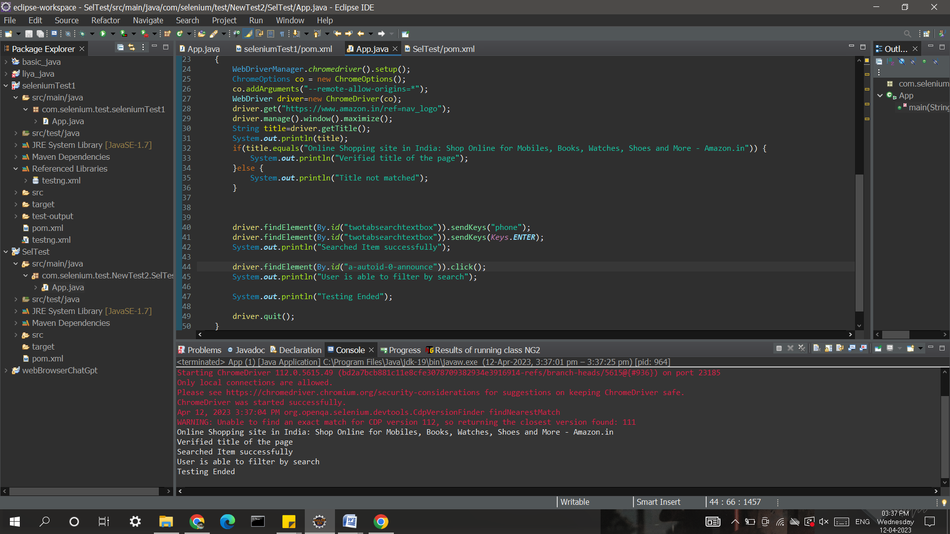

package com.selenium.test.NewTest2.SelTest;

import java.util.List;

import org.openqa.selenium.By;

import org.openqa.selenium.JavascriptExecutor;

import org.openqa.selenium.Keys;

import org.openqa.selenium.WebDriver;

import org.openqa.selenium.WebElement;

import org.openqa.selenium.chrome.ChromeDriver;

import org.openqa.selenium.chrome.ChromeOptions;

import org.openqa.selenium.support.ui.Select;

import io.github.bonigarcia.wdm.WebDriverManager;

public class App

{

public static void main( String[] args ) throws InterruptedException

{

WebDriverManager.chromedriver().setup();

ChromeOptions co = new ChromeOptions();

co.addArguments("--remote-allow-origins=*");

WebDriver driver=new ChromeDriver(co);

driver.get("https://www.amazon.in/ref=nav_logo");

driver.manage().window().maximize();

String title=driver.getTitle();

System.out.println(title);

if(title.equals("Online Shopping site in India: Shop Online for Mobiles, Books, Watches, Shoes and More - Amazon.in")) {

System.out.println("Verified title of the page");

}else {

System.out.println("Title not matched");

}

driver.findElement(By.id("twotabsearchtextbox")).sendKeys("phone");

driver.findElement(By.id("twotabsearchtextbox")).sendKeys(Keys.ENTER);

System.out.println("Searched Item successfully");

driver.findElement(By.id("a-autoid-0-announce")).click();

List<WebElement>li=driver.findElements(By.xpath("//*[@id=\"octopus-dlp-asin-stream\"]/ul/li[2]/span/div/div[2]/div[1]/a"));

for(WebElement link:li) {

System.out.println(link.getText());

}

System.out.println("User is able to filter by search");

System.out.println("Testing Ended");

driver.quit();

}

}

3. 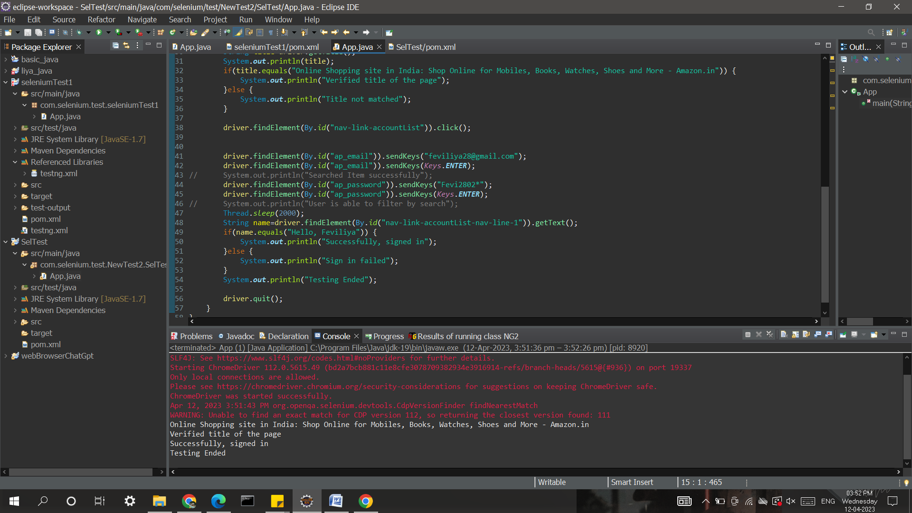

package com.selenium.test.NewTest2.SelTest;

import java.util.List;

import org.openqa.selenium.By;

import org.openqa.selenium.JavascriptExecutor;

import org.openqa.selenium.Keys;

import org.openqa.selenium.WebDriver;

import org.openqa.selenium.WebElement;

import org.openqa.selenium.chrome.ChromeDriver;

import org.openqa.selenium.chrome.ChromeOptions;

import org.openqa.selenium.support.ui.Select;

import io.github.bonigarcia.wdm.WebDriverManager;

/**

* Hello world!

*

*/

public class App

{

public static void main( String[] args ) throws InterruptedException

{

WebDriverManager.chromedriver().setup();

ChromeOptions co = new ChromeOptions();

co.addArguments("--remote-allow-origins=*");

WebDriver driver=new ChromeDriver(co);

driver.get("https://www.amazon.in/ref=nav_logo");

driver.manage().window().maximize();

String title=driver.getTitle();

System.out.println(title);

if(title.equals("Online Shopping site in India: Shop Online for Mobiles, Books, Watches, Shoes and More - Amazon.in")) {

System.out.println("Verified title of the page");

}else {

System.out.println("Title not matched");

}

driver.findElement(By.id("nav-link-accountList")).click();

driver.findElement(By.id("ap_email")).sendKeys("feviliya28@gmail.com");

driver.findElement(By.id("ap_email")).sendKeys(Keys.ENTER);

driver.findElement(By.id("ap_password")).sendKeys("Fevi2802*");

driver.findElement(By.id("ap_password")).sendKeys(Keys.ENTER);

Thread.sleep(2000);

String name=driver.findElement(By.id("nav-link-accountList-nav-line-1")).getText();

if(name.equals("Hello, Feviliya")) {

System.out.println("Successfully, signed in");

}else {

System.out.println("Sign in failed");

}

System.out.println("Testing Ended");

driver.quit();

}

}

NALLASIVAM P V

II IT-B

727721EUIT096

PART-A&B

1)

package CC2;

import org.openqa.selenium.By;

import org.openqa.selenium.WebDriver;

import org.openqa.selenium.chrome.ChromeDriver;

import org.openqa.selenium.chrome.ChromeOptions;

import org.testng.annotations.Test;

import io.github.bonigarcia.wdm.WebDriverManager;

public class NewTest_1 {

WebDriver d;

*@Test*

public void f() throws InterruptedException {

ChromeOptions co=new ChromeOptions();

co.addArguments("--remote-allow-origins=*");

WebDriverManager.*chromedriver*().setup();

d=new ChromeDriver(co);

d.get("https://www.yatra.com/flights");

d.manage().window().maximize();

Thread.*sleep*(4000);

d.findElement(By.*xpath*("//*[@id=\"booking_engine_flights\"]")).click();

Thread.*sleep*(2000);

d.findElement(By.*xpath*("//*[@id=\"BE_flight_form_wrapper\"]/div[1]/div[1]/ul[1]/li[2]/a")).click();

Thread.*sleep*(2000);

d.findElement(By.*xpath*("//*[@id=\"BE_flight_origin_city\"]")).click();

Thread.*sleep*(2000);

d.findElement(By.*xpath*("//*[@id=\"BE_flight_form_wrapper\"]/div[1]/div[2]/ul/li[1]/ul/li[1]/div/div/ul/div/div/div/li[4]")).click();

Thread.*sleep*(2000);

d.findElement(By.*xpath*("//*[@id=\"BE_flight_form_wrapper\"]/div[1]/div[2]/ul/li[1]/ul/li[3]/div/div/ul/div/div/div/li[3]")).click();

Thread.*sleep*(2000);

d.findElement(By.*xpath*("//*[@id=\"BE_flight_origin_date\"]")).click();

Thread.*sleep*(2000);

d.findElement(By.*xpath*("//*[@id=\"20/04/2023\"]")).click();

Thread.*sleep*(2000);

d.findElement(By.*xpath*("//*[@id=\"BE_flight_arrival_date\"]")).click();

Thread.*sleep*(2000);

d.findElement(By.*xpath*("//*[@id=\"24/04/2023\"]")).click();

Thread.*sleep*(2000);

d.findElement(By.*xpath*("//*[@id=\"BE_flight_paxInfoBox\"]/i")).click();

Thread.*sleep*(2000);

d.findElement(By.*xpath*("//*[@id=\"BE_flight_passengerBox\"]/div[1]/div[1]/div/div/span[2]")).click();

Thread.*sleep*(2000);

d.findElement(By.*xpath*("//*[@id=\"flight_class_select_child\"]/ul/li[3]")).click();

Thread.*sleep*(2000);

d.findElement(By.*xpath*("//*[@id=\"BE_flight_form_wrapper\"]/div[3]/div[1]/div[1]/a/i")).click();

Thread.*sleep*(2000);

d.findElement(By.*xpath*("//*[@id=\"BE_flight_flsearch_btn\"]")).click();

}

}

OUTPUT:

